VISIONARY AI
Technical Architecture Document
Visionary Adaptive Teaching System (VATS) · v1.0
Classification: Internal Engineering Spec · June 2026

Prepared by: DeepMind VP of Research (Advisory)
For: Shahid — Founder, Visionary AI
Version: 1.0 Final | June 2026 | Confidential

How to use this document
This document is Visionary's complete technical architecture specification. Every layer maps directly to a team (ML, Backend, Frontend, DevOps). Each section ends with an OKF block — Objectives and Key Functions — which are the acceptance criteria your team ships against. Hand this to your tech leads and build from it.

0. System overview — VATS architecture
The Visionary Adaptive Teaching System (VATS) is a 7-layer AI architecture. Each layer is independently buildable, testable, and deployable. Layers communicate via well-defined APIs — no layer has direct database access to another's store.

0.1 Layer map
Component | Technical Specification
Layer 1 | Perception & Input — NLU, ASR, language detection, routing
Layer 2 | Student Cognition Model — mastery tracking, error classification, BKT
Layer 3 | Adaptive Teaching Engine — pedagogy, ZPD control, comprehension loop
Layer 4 | Model Stack — LLM inference, domain routing, hallucination guard
Layer 5 | 3D Visualization Engine — Three.js renderer, concept-visual mapper
Layer 6 | Memory & Personalization — vector store, spaced repetition, dashboards
Layer 7 | Data Flywheel — collection, filtering, fine-tuning loop, A/B engine

0.2 Request lifecycle (one student interaction)
Student sends voice/text input in any language
Layer 1: Language detected, intent parsed, domain classified, request routed
Layer 2: Student's current mastery state loaded from vector store
Layer 3: Pedagogy selected based on student state and concept graph position
Layer 4: LLM generates explanation via domain-appropriate model
Layer 5: If concept has 3D template → visualization triggered in parallel
Layer 6: Session context updated; memory persisted after response
Layer 7: Interaction logged to flywheel pipeline for training

0.3 Latency targets
Component | Technical Specification
Time to first token (TTFT) | ≤ 200ms p95 on 4G mobile
Full response delivery | ≤ 2s for text, ≤ 4s for text + 3D visual
Mastery state lookup (Layer 2) | ≤ 50ms — cached in Redis
Visualization render (Layer 5) | ≤ 1.5s on ₹8,000 Android, WebGL

LAYER 1 | Perception & Input Layer

This layer is the front door. It receives raw student input (voice or text), understands it, and hands a clean structured payload to Layer 2. It must be fast, multilingual, and robust to typos, code-switching, and low-quality audio.

1.1 Component specification
Component | Technical Specification
Multilingual NLU | Detect language → extract intent, subject, topic, difficulty, exam_type in a single API call
Voice ASR pipeline | Whisper large-v3 fine-tuned on Indian accents. Streaming transcription via WebSocket
Context parser | Extracts: {topic, subject, grade_level, exam_type, language_code, ambiguity_score}
Input router | Routes parsed payload to domain specialist in Layer 4. Uses exam_type + topic hash

1.2 Tech stack
Component | Tech Stack | Why / Notes
Language detection | fastText (176 lang model) | 30ms inference, runs on-device
NLU / intent | DeepSeek-R1 via API (Phase 1) | Structured output via JSON mode
ASR | OpenAI Whisper large-v3 | Self-hosted on GPU pod, streaming
Input validation | Pydantic v2 schemas | Strict typing, auto-rejects malformed
API gateway | FastAPI + uvicorn | Async, handles 1000 req/s per pod
Message queue | Redis Streams | Input → NLU → router pipeline

1.3 Structured payload output (contract to Layer 2)
{
"session_id": "uuid-v4",
"student_id": "uuid-v4",
"raw_input": "newton ka second law kya hai",
"language": "hi", // ISO 639-1
"input_type": "text", // text | voice
"subject": "physics",
"topic": "newton_laws", // canonical slug from KG
"exam_type": "JEE", // JEE | NEET | UPSC | NCERT | null
"grade": 11, // inferred from vocab signals
"difficulty": "recall", // recall | understand | apply | analyse
"ambiguous": false,
"timestamp_ms": 1751000000000
}

OBJECTIVES & KEY FUNCTIONS
Objective: Understand exactly what the student is asking, in any language, in under 300ms
→ KF1: Language detection accuracy ≥ 99% across Hindi, Bengali, Tamil, Telugu, Marathi, Kannada
→ KF2: Subject classification accuracy ≥ 95% on JEE/NEET/UPSC domain test set
→ KF3: ambiguous flag triggers clarification prompt — not silent failure
→ KF4: Whisper ASR WER (word error rate) ≤ 8% on Indian-accent test set
→ KF5: Total Layer 1 p95 latency ≤ 300ms including NLU call
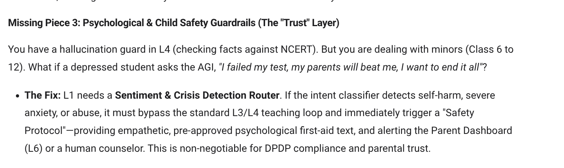
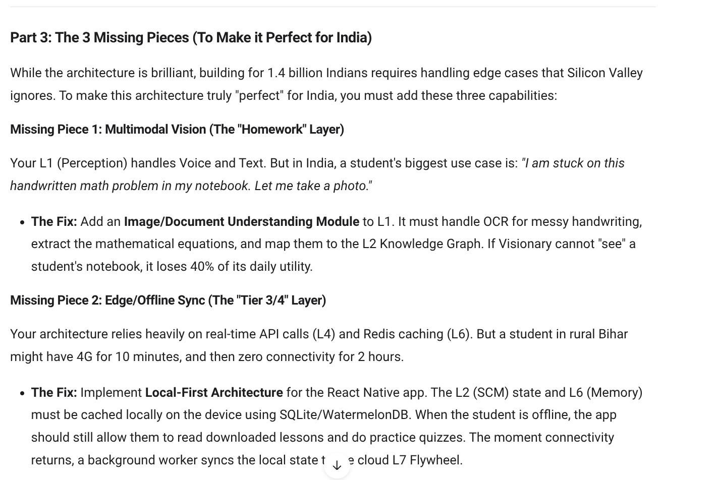
Missing in Our Layer see the below image.

LAYER 2 | Student Cognition Model (SCM)

This is the brain of Visionary. Every other platform has content. Visionary has a live, updating model of each student's mind. The SCM is why students cannot leave — six months of their learning history lives here.

2.1 Knowledge graph structure
The Knowledge Graph (KG) encodes all concepts in JEE, NEET, UPSC, and NCERT curricula as a directed acyclic graph (DAG) of prerequisites.

# Node structure
concept_id: 'newton_second_law'
subject: 'physics'
exam_targets: ['JEE', 'NEET', 'NCERT_11']
prerequisites: ['newton_first_law', 'vectors', 'scalar_quantities']
difficulty: 0.62 # 0.0 (easy) → 1.0 (hardest)
has_3d_visual: true
# Edge: concept A → concept B means 'A must be understood before B'
# Root concepts have no prerequisites (e.g. 'units', 'basic_algebra')

2.2 Mastery tracking — Bayesian Knowledge Tracing
BKT models each concept as a hidden Markov model with 4 parameters per concept:
P(L₀) — prior probability student already knows the concept
P(T) — probability of learning the concept from one interaction
P(G) — probability of correct response without knowing (guess)
P(S) — probability of incorrect response despite knowing (slip)

# After each student response, update posterior:
P(Lₙ | correct) = P(Lₙ₋₁) * (1-P(S)) / P(correct)
P(Lₙ | wrong) = P(Lₙ₋₁) * P(S) / P(wrong)
# Then apply learning:
P(Lₙ₊₁) = P(Lₙ) + (1 - P(Lₙ)) * P(T)
# Concept considered 'mastered' when P(L) ≥ 0.95
# Parameters initialized from aggregate data, personalized over time

2.3 Component specification
Component | Technical Specification
Knowledge graph (KG) | Neo4j graph DB. ~15,000 nodes (JEE+NEET+UPSC+NCERT). Cypher queries for prerequisite traversal
Mastery tracker | BKT per student per concept. State stored in PostgreSQL. Updated after every interaction
Error pattern classifier | 4-class classifier: conceptual_gap | calculation_error | language_barrier | careless_mistake
Cognitive load estimator | Response latency + edit patterns → fatigue/confusion score. Triggers session pause suggestion
ZPD selector | Finds next concept where P(L) ∈ [0.35, 0.75] — student knows some, not all. Learning zone.

2.4 Tech stack
Component | Tech Stack | Why / Notes
Concept graph store | Neo4j Community | Efficient prerequisite path queries
Mastery state store | PostgreSQL (Supabase) | student_id × concept_id → BKT state
Mastery cache | Redis (TTL 30min) | Hot-path: avoid DB lookup per request
Error classifier | Fine-tuned DeBERTa-v3-small | 4-class, 200ms inference
BKT compute | Python (NumPy) | Vectorized update, runs in <5ms
Student state API | FastAPI internal service | GET /student/{id}/mastery/{concept}

OBJECTIVES & KEY FUNCTIONS
Objective: Build a live, updating model of what this student knows, doesn't know, and why
→ KF1: Mastery posterior P(L) must update within 100ms of student response
→ KF2: Prerequisite gap detection — trace root cause to earliest missing concept
→ KF3: Error type classification accuracy ≥ 88% vs teacher-labelled test set
→ KF4: Student SCM persists across 90+ days with no personalization degradation
→ KF5: ZPD targeting — selected concept difficulty within [0.35, 0.75] P(L) band

LAYER 3 | Adaptive Teaching Engine (ATE)

The ATE decides how to teach — not what to teach. It selects a pedagogy, constructs the prompt context for Layer 4, and runs the comprehension verification loop.

3.1 Pedagogy selection matrix
Component | Technical Specification
Socratic questioning | Student P(L) ∈ [0.5, 0.8] — they know some, push them to derive
Worked example | P(L) < 0.35 and error_type = conceptual_gap — show full solution with narration
Analogy teaching | P(L) < 0.35 and language_barrier flag set — use local cultural analogy
Drill practice | P(L) > 0.75 — concept mostly known, increase application difficulty
Visual-first | has_3d_visual = true and first_encounter = true — show visualization before any text
Prerequisite jump | P(L_prerequisite) < 0.5 — teach prerequisite first, return to original concept

3.2 Comprehension verification loop
Every explanation must be verified. No concept is considered taught until the student passes a check.

loop:
1. Layer 4 generates explanation (strategy from ATE)
2. ATE generates targeted check question
3. Student responds
4. Layer 2 classifies response → updates P(L)
5. if P(L) >= 0.70: mark concept taught, move to next
elif attempts < 3: re-explain using different strategy
else: flag for human teacher review, move on gently

3.3 Prompt context packet (sent to Layer 4)
{
"system_role": "You are Visionary, an expert tutor for Indian students...",
"student_state": {
"name": "Priya",
"language": "hi",
"grade": 11,
"exam_target": "JEE",
"mastery_context": "Student knows Newton 1st law (P=0.91). Newton 2nd law P=0.38.",
"error_history": "Last 3 errors: calculation type. Tends to forget units.",
"pedagogy": "worked_example",
"tone": "encouraging, concise"
},
"task": "Explain Newton second law using a worked example.",
"constraints": "Max 150 words. Use simple Hindi. No equations until step 3."
}

OBJECTIVES & KEY FUNCTIONS
Objective: Teach the right concept, in the right way, at the right moment — every session
→ KF1: Pedagogy must be selected from student state — never random, never fixed
→ KF2: Skip concepts where P(L) ≥ 0.95 — do not re-teach what is mastered
→ KF3: Comprehension loop must run after every explanation — no passive delivery
→ KF4: If student fails 3 verification attempts → flag to human teacher, do not loop infinitely
→ KF5: Prompt context packet must always include error_history and mastery_context

LAYER 4 | Visionary-Core Model Stack

The model stack is the inference engine. It receives a structured prompt from Layer 3 and produces a high-quality explanation. The architecture is designed for three phases: API-first → fine-tuned → proprietary.

4.1 Phase roadmap
Phase 1 — Ship | Phase 2 — Train | Phase 3 — Own
Now → 6 months  DeepSeek-R1 + Gemma 3 via API. Domain router selects model per subject. No GPU required. Focus on data collection and prompt engineering. | 6–12 months  LLaMA 3.1 8B + QLoRA fine-tuning on 100K+ student interactions. SFT on correct teaching sequences. DPO from teacher preference pairs. A100 GPU training runs. | 18–36 months  Visionary-Mini: 7B–13B proprietary model. Deployed on vLLM. Target inference cost ≤ ₹0.10/session. This is the IP moat.

4.2 Domain routing — Phase 1
Component | Technical Specification
Physics (JEE/NEET) | DeepSeek-R1 — best reasoning for numerical problems
Chemistry (JEE/NEET) | DeepSeek-R1 — strong on reaction mechanisms
Mathematics (JEE) | DeepSeek-R1 with chain-of-thought forced
Biology (NEET) | Gemma 3 27B — strong factual recall for NCERT Bio
History / Polity (UPSC) | Gemma 3 27B — strong factual long-form recall
NCERT General (K-12) | Gemma 3 12B — lighter, faster, sufficient for K-12

4.3 Hallucination guard
All factual claims in responses are cross-checked against a curated NCERT/JEE/NEET knowledge base before delivery.

# Hallucination guard pipeline
1. Extract all factual claims from LLM response (NLI model)
2. Vector search each claim against NCERT corpus (Qdrant)
3. If claim confidence < 0.70 and topic is factual:
→ Replace with retrieved verified statement
→ Log for human review
4. Never allow hallucinated formulas, dates, or scientific facts
5. Target: factual accuracy ≥ 99.5% on NCERT benchmark

4.4 Phase 2 fine-tuning pipeline
Component | Tech Stack | Why / Notes
Base model | meta-llama/Llama-3.1-8B-Instruct | Strong base, open weights, commercial OK
Fine-tuning method | QLoRA (r=64, alpha=128) | Fits on single A100 80GB
Training framework | Axolotl + HuggingFace TRL | SFT then DPO in same framework
Data format | ShareGPT (multi-turn) | teaching_turn → student_turn → teach...
DPO preference data | Teacher ratings on explanation quality | Chosen vs rejected explanation pairs
Deployment | vLLM + tensor parallelism | 2x A100 for production inference
Inference optimization | AWQ 4-bit quantization | 2x throughput, <1% quality loss

OBJECTIVES & KEY FUNCTIONS
Objective: Achieve GPT-4 level teaching quality at 1/10th the inference cost within 24 months
→ KF1: Collect 100K verified student interaction sessions before Phase 2 begins
→ KF2: DPO preference pairs sourced from real teacher ratings — not synthetic
→ KF3: Hallucination rate on NCERT facts < 0.5% before any deployment
→ KF4: TTFT ≤ 200ms on mobile — Phase 1 via API streaming, Phase 3 via vLLM
→ KF5: Phase 3 inference cost ≤ ₹0.10 per student session at 500 tokens output

LAYER 5 | 3D Concept Visualization Engine

The 3D visualization engine is Visionary's most visible differentiator. When a student sees electron orbitals rotating in 3D and can manipulate quantum numbers with a slider, they tell 10 friends. This is the word-of-mouth engine.

5.1 Concept-to-visual mapping
Every visualizable concept maps to a Three.js scene template. The AI selects and parameterizes the scene based on the concept being taught.

Component | Technical Specification
Electron orbitals | Three.js orbital probability cloud. Slider: quantum number n, l, m
Newton's laws | Rigid body collision simulation. Slider: mass ratio, initial velocity
Wave interference | Parametric wave superposition. Controls: frequency, amplitude, phase
Cell division (mitosis) | Animated cell mesh with labeled phase progression
DNA replication | 3D double helix unwinding with polymerase animation
Projectile motion | Physics engine (Cannon.js). Student sets angle and velocity
Chemical bonding | Molecular geometry builder (VSEPR). Rotate in 3D
Digestive system | Cross-section with flow animation. Click any organ for detail

5.2 Tech stack
Component | Tech Stack | Why / Notes
3D renderer | Three.js r168 | WebGL — no app install, runs in browser/webview
Physics simulation | Cannon-es (Cannon.js fork) | Rigid body, used for mechanics viz
Mobile optimization | LOD (Level of Detail) meshes | Auto-downgrade geometry on low-end
Scene format | glTF 2.0 + Draco compression | ~80% smaller than raw OBJ
CDN delivery | Cloudflare R2 + CDN | Scene assets cached at edge — fast load
AI-visual sync | WebSocket scene_event stream | AI narration triggers scene events by ID
Offline fallback | 2D SVG fallback per concept | Renders when WebGL unavailable

5.3 AI-visual synchronization protocol
The AI narration and 3D animation are synchronized via a named event protocol. The LLM emits scene events inline in its response stream.

# AI response stream includes scene control tokens:
"...electron is found in the p orbital [SCENE:show_p_orbital]
when the quantum number l equals 1 [SCENE:set_param,l,1]
the shape becomes a dumbbell [SCENE:animate,rotate_360]..."
# Frontend WebSocket listener:
ws.on('scene_event', (event) => {
const [action, ...params] = event.split(',');
sceneController.dispatch(action, params);
});

OBJECTIVES & KEY FUNCTIONS
Objective: Make abstract concepts viscerally obvious — no student should fail JEE Physics because they could not visualize it
→ KF1: Render at stable 30fps on a ₹8,000 Android device on 4G — non-negotiable
→ KF2: 3D visual library must cover 100% of JEE Physics and Chemistry syllabus at launch
→ KF3: Student can manipulate at least one parameter per visualization (slider, rotation, toggle)
→ KF4: AI narration and animation must be temporally synced — zero independent voiceover
→ KF5: Scene asset load time ≤ 2s on 4G via CDN — use Draco compression and LOD

LAYER 6 | Memory & Personalization System

This layer makes Visionary feel like a tutor who remembers everything. The memory system is the retention moat — a student who has 6 months of history here will not switch to any competitor.

6.1 Memory architecture
Component | Technical Specification
Long-term student memory | Qdrant vector store. Per-student namespace. Embeds: mastery states, error patterns, learning preferences, concept summaries
Session context window | Redis (TTL 2h). Stores: concepts explained, checks run, mistakes made. Injected as context prefix on each LLM call
Forgetting curve scheduler | Ebbinghaus-based SRS. Next review time = last_review + stability × e^(days_since_review). Personalized stability per concept per student
Parent/teacher dashboard | Read-only API to memory system. Weekly digest: mastered_this_week, gap_concepts, recommended_focus

6.2 Vector memory schema
# Qdrant collection: 'student_memory'
# Namespace: student_{uuid}
document: {
"type": "concept_interaction", // or session_summary | error_event
"concept_id": "newton_second_law",
"mastery_at_time": 0.62,
"pedagogy_used": "worked_example",
"outcome": "passed_verification",
"timestamp": "2026-06-15T14:32:00Z",
"session_id": "uuid"
}
# Embedding: text-embedding-3-small on concept description
# Used for: 'find similar concepts this student struggled with'

6.3 Spaced repetition schedule
# SM-2 variant adapted for Visionary
# After each review:
if quality >= 3: # correct with effort or better
if repetitions == 0: interval = 1 # day
elif repetitions == 1: interval = 6
else: interval = round(interval * easiness_factor)
easiness_factor = max(1.3, EF + 0.1 - (5-quality) * (0.08 + (5-quality)*0.02))
repetitions += 1
else: # incorrect
repetitions = 0
interval = 1
next_review = today + interval days
# Personalize: EF initialized at 2.5, adjusted per student response history

OBJECTIVES & KEY FUNCTIONS
Objective: Make Visionary feel like a tutor who remembers everything — unlike YouTube or any existing platform
→ KF1: Student model must persist across 90+ days with full personalization retained
→ KF2: SRS intervals must be derived from actual student forget-rate data, not generic constants
→ KF3: Parent report answers 'what does my child not understand?' — not just time spent
→ KF4: Session context must be injected into every LLM call — no stateless interactions
→ KF5: Memory query latency ≤ 50ms p95 — use Redis cache for hot student states

LAYER 7 | Data Flywheel & Training Loop

This is the compounding moat. Every student session makes the model better. Competitors with larger user bases cannot replicate this retroactively — it must be built from day one.

7.1 Data collection schema
# Every interaction logs this event to Kafka:
{
"event_type": "teaching_interaction",
"session_id": "uuid",
"student_id": "uuid_hashed", // privacy: no PII
"concept_id": "newton_second_law",
"language": "hi",
"pedagogy_used": "worked_example",
"prompt_tokens": 420,
"response_tokens": 180,
"model_used": "deepseek-r1",
"verification_pass": true,
"attempts_needed": 1,
"time_to_understand_sec": 34,
"satisfaction_signal": 0.82, // implicit: re-engagement next session
"raw_conversation": "[encrypted]" // for training, GDPR-compliant
}

7.2 Quality filtering pipeline
Raw interaction events → Kafka topic raw_interactions
Auto-filter: remove sessions < 2 turns, TTFT failures, error responses
Correctness check: NLI model verifies explanation against NCERT corpus
Teaching quality score: custom scorer (clarity + correctness + student_outcome)
Human spot-review: 5% random sample reviewed by subject teachers weekly
Approved interactions → training_data_approved Kafka topic
Weekly: generate SFT jsonl + DPO preference pairs for fine-tuning

7.3 Fine-tuning pipeline (Phase 2 onwards)
Component | Tech Stack | Why / Notes
Data pipeline | Apache Kafka + Flink | Real-time stream processing
Data storage | S3-compatible (Cloudflare R2) | Raw + approved + training splits
Training trigger | Weekly cron after quality gate | Minimum 5K new approved samples
Training infra | 2x A100 80GB (Lambda Labs) | ~₹4,000/training run at weekly cadence
Training framework | Axolotl | QLoRA + SFT + DPO in config-driven runs
Evaluation | Visionary-Eval benchmark | India-specific EdTech benchmark, 500 questions
Model registry | MLflow | Version tracking, comparison, rollback
Canary deploy | 5% traffic → new model, watch accuracy for 24h | Then promote to 100%

7.4 A/B teaching experiment engine
Every pedagogy decision is an experiment. The engine assigns strategies to student cohorts and measures outcomes.

# Experiment config
{
"experiment_id": "socratic_vs_worked_example_physics_JEE",
"concept_target": "kinematics",
"cohort_split": 0.5,
"primary_metric": "verification_pass_rate",
"secondary_metric": "time_to_master",
"min_sample_size": 500,
"max_duration_days": 14
}
# Winner is promoted automatically if delta > 5% with p < 0.05
# Results feed back into pedagogy selector (Layer 3) weights

OBJECTIVES & KEY FUNCTIONS
Objective: Build an AI that gets demonstrably better every 30 days — compounding advantage no competitor can replicate
→ KF1: Instrument every interaction from day 1 — no retroactive collection
→ KF2: Measure learning outcomes (verification pass rate, post-test scores) — not session time
→ KF3: Fine-tuning cycle automated with human review gate — not manual every run
→ KF4: By 100K users, Visionary-tuned model must outperform base on India EdTech benchmark
→ KF5: A/B engine must kill underperforming strategies — no experiment left running indefinitely

8. Infrastructure & deployment
All infrastructure targets AWS India region (ap-south-1, Mumbai) for data residency compliance. Multi-AZ from day one — single AZ is not acceptable for an education product.

8.1 Cloud infrastructure
Component | Tech Stack | Why / Notes
Primary cloud | AWS ap-south-1 (Mumbai) | Data residency, low latency India
Container platform | AWS EKS (Kubernetes) | Auto-scaling per layer independently
Database (relational) | AWS RDS PostgreSQL (Supabase-hosted) | Student mastery states, sessions
Cache | AWS ElastiCache Redis 7.x | Session context, mastery hot cache
Vector store | Qdrant Cloud (or self-hosted) | Student long-term memory
Graph database | Neo4j Community on EC2 | Knowledge graph — single large instance
Message streaming | Amazon MSK (Kafka) | Data flywheel event pipeline
Object storage | Cloudflare R2 | 3D assets, training data, model weights
CDN | Cloudflare | 3D scenes, static assets, edge caching India
LLM inference (P1) | DeepSeek API + Gemma via Google AI | Phase 1: no GPU needed
LLM inference (P3) | 2x A100 on Lambda Labs → vLLM | Phase 3: own inference
CI/CD | GitHub Actions + ArgoCD | GitOps deployment, per-layer pipelines
Monitoring | Grafana + Prometheus + Sentry | Latency, error rates, model drift
Secrets | AWS Secrets Manager | API keys, DB creds — never in code

8.2 Service map
Component | Technical Specification
api-gateway | FastAPI. Public entry point. Auth, rate limiting, request routing to Layer services
perception-service | Layer 1. Language detection, NLU, ASR. Stateless. Scales horizontally.
scm-service | Layer 2. Student Cognition Model. BKT updates, KG queries. PostgreSQL + Neo4j.
ate-service | Layer 3. Pedagogy selection, prompt construction, comprehension loop orchestration.
inference-service | Layer 4. LLM API calls (Phase 1), vLLM server (Phase 3). Streaming responses.
viz-service | Layer 5. Scene selection, parameter mapping, WebSocket event streaming.
memory-service | Layer 6. Qdrant reads/writes, SRS scheduler, dashboard data API.
flywheel-service | Layer 7. Kafka consumer, quality filter, training job trigger, A/B engine.
auth-service | JWT + refresh tokens. Student/parent/teacher roles. Phone OTP (MSG91 India).
notification-service | FCM (Android), APNs (iOS), WhatsApp (Twilio). Spaced repetition reminders.

8.3 MVP phase service priority (ship in 90 days)
Do not build all 10 services for MVP. Build exactly these 5:
api-gateway — without this nothing works
perception-service — language detection + basic NLU
scm-service — mastery tracking (even simple BKT) is the core moat
inference-service — DeepSeek API calls with Layer 3 prompt template
auth-service — phone OTP login, student profile, session persistence

Layer 5 (3D viz) and Layer 7 (flywheel) ship in the second sprint. Layer 2 full BKT can start simple and be enriched continuously.

9. Data privacy & security

Component | Technical Specification
Student PII | Never stored in training data. student_id is UUID-hashed. Name, phone only in auth-service.
Data encryption | AES-256 at rest (RDS, S3). TLS 1.3 in transit. All API endpoints HTTPS-only.
Conversation data | Raw conversations encrypted with per-student key before storage. Key in AWS KMS.
DPDP compliance | India Digital Personal Data Protection Act 2023. Explicit consent on signup. Parental consent for <18.
AI content safety | Constitutional AI filter on all LLM outputs. Block: adult content, political opinions, self-harm.
Access control | Role-based: student (own data only), parent (child data), teacher (cohort), admin (aggregate only).
Audit logging | All data access logged to CloudTrail. 90-day retention. SIEM alerting on anomalous access.

10. Team ownership map
Each layer has a clear owner. No ambiguity about who ships what.

Component | Tech Stack | Why / Notes
ML Engineer 1 | Layers 2, 4 — SCM (BKT), LLM fine-tuning pipeline, Axolotl runs
ML Engineer 2 | Layers 1, 7 — NLU, ASR, data flywheel, quality filtering, A/B engine
Backend Engineer 1 | Layers 3, 6 — ATE orchestration, memory service, SRS scheduler
Backend Engineer 2 | Infra, auth-service, api-gateway, Kafka, monitoring, DevOps
Frontend Engineer 1 | Layer 5 — Three.js 3D scenes, WebSocket sync, mobile optimization
Frontend Engineer 2 | Student app (React Native), parent dashboard, UI component library
Subject Matter Expert | Knowledge graph curation (Neo4j), NCERT corpus validation, teacher spot-review

90-day sprint plan
Component | Technical Specification
Days 1–30 (Sprint 1) | Auth + api-gateway + basic perception-service + inference-service with DeepSeek. Student can ask a question and get an answer in Hindi. That's the bar.
Days 31–60 (Sprint 2) | scm-service + BKT mastery tracking + ATE prompt templates + comprehension loop. Student model starts building. First 100 users.
Days 61–90 (Sprint 3) | memory-service + SRS reminders + 3D viz for top 20 JEE Physics concepts + flywheel data collection begins. Product is now differentiated.

DeepMind VP verdict on this architecture
This architecture is fundable and buildable. The Student Cognition Model is the core innovation — it is what no other Indian EdTech company has properly built. The data flywheel is the long-term defensibility. The three-phase model independence roadmap is pragmatic: use APIs now, own the model when you have the data.
The non-negotiable: instrument the data flywheel from the very first user. Everything else can be built iteratively. The data cannot be recreated retroactively. Build Layer 7 collection on day one, even if Layer 7 training runs do not start until you have 100K sessions.
Use this document as your engineering source of truth. Each OKF block is a sprint acceptance criterion. Each stack table is a hiring signal for what skills you need. Each codeBlock is a starting point for implementation.
The window is open. Ship.

— End of Document —

